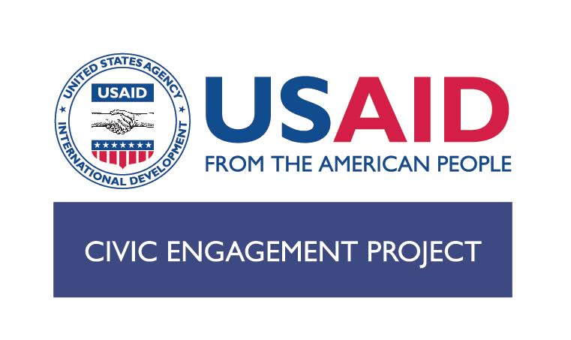

Request for Applications (RfA)# CEP-PG-01

Partnership Grants

USAID’s Civic Engagement Project invites civil society organizations (CSO) alliances in Macedonia to apply for Partnership Grants. The CSO alliances include legally registered and not registered CSO coalitions, platforms, networks, and alliances comprised of more than five member CSOs.

The Civic Engagement Project is a five year USAID-funded program that contributes to achieve two objectives: (1) strengthened influence of CSOs on policies and programs related to priority issues of citizen concern; and (2) increased and sustained youth engagement in public life in Macedonia. The Partnership Grants will be managed by Metamorphosis.

The aim of the Partnership Grants is to support CSO alliances to: (i) become leaders in shaping and constructively engaging in issues of public concern; (ii) enhance their capacity to engage citizens, media, government institutions and other stakeholders in advancing the public’s wellbeing ; and (iii) strengthen their institutional capacity.

The Civic Engagement Project will award up to (2) grants under this RfA. The maximum grant award for each proposal is 120,000 USD, and is for activities lasting up to 3 (three) years. The Project reserves the right to fund any or none of the applications submitted.

Grant activities could include:
- Advocacy, monitoring, public policy analysis, and public education initiatives in the following areas: good governance, public service improvement, rule of law, anti-corruption, human rights, economic growth, business enabling environment, and monitoring and oversight of public institutions; and
- CSO alliance’s capacity development activities, that could include establishing and providing membership services to CSO alliance’s members; expanding the CSO alliances with a variety of stakeholders including region-based CSOs, CSO that represent socially excluded groups, or/and the private sector, media, as well as the academia; working constantly, persistently, and creatively to engage citizens and various constituencies, i.e., media, private sector, and the government, in all aspects of the CSO alliances’ work; and strengthening CSO alliances’ networking with relevant stakeholders in South East Europe and beyond.

To download the full Request for Application, the Application Form, and the Budget Template for Partnership Grants, please go to www.metamorphosis.org.mk or write to Gordana Mirchikj at gmirchikj@ewmi.org.

DEADLINE FOR SUBMITTING PROPOSALS: 16:30, DECEMBER 23, 2016

